**What’s your name?**

**My name is**

**……………………**

What’s your name?

My name is

……………………..

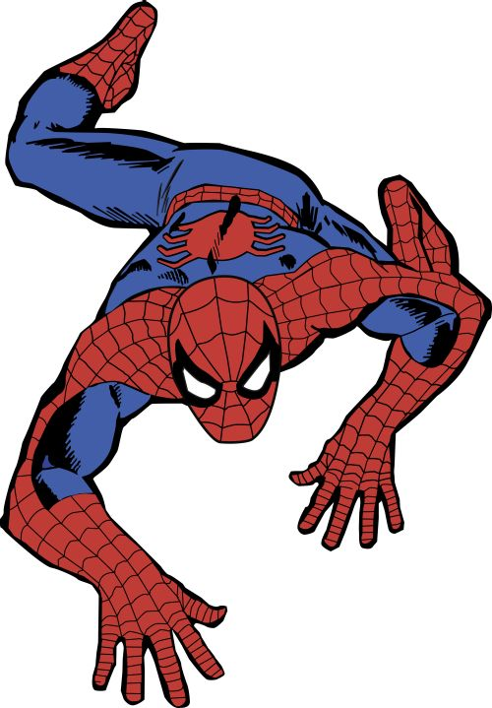

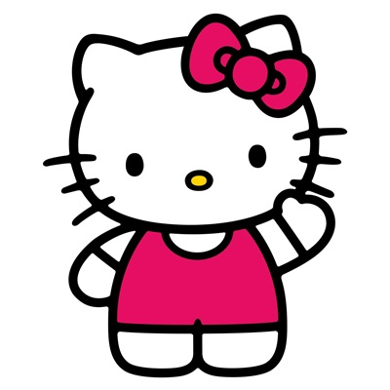

**What’s your name?**

**My name is**

**……………………..**

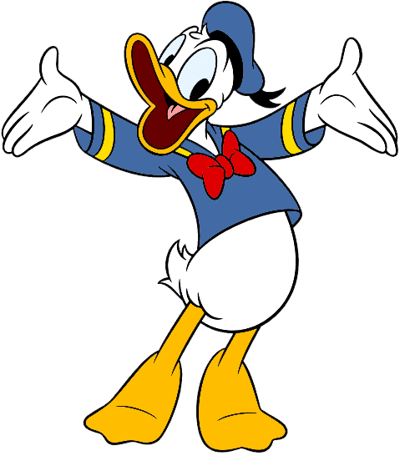

Tvoj portrét

What’s your name?

My name is

……………………….

*Tvoj*